Project Report

on

**“EMPLOYEE LEAVE & INFORMATION MANAGEMENT SYSTEM”**

In  
the partial fulfillment for the award of degree of Master of Computer Applications



**Project Guide: Submitted By:**

Mr. Nitin Deepak Abhay Pratap Singh

Ashish Joshi

Bhupesh Bam

Bhupesh Pathak

Deepak Singh

**Submitted to**:

Department of Computer Science

Amrapali Institute of Management & Computer Applications, Haldwani

**ACKNOWLEDGEMENT**

The satisfaction that accompanies that the successful completion of any task would be incomplete without the mention of people whose ceaseless cooperation made it possible, whose constant guidance and encouragement crown all efforts with success.

We are grateful to our project guide Mr. NITIN DEEPAK for the guidance, inspiration and constructive suggestions that helpful us in the preparation of this project.

We also thank our colleagues who have helped in successful completion of the project.

Abhay Pratap Singh

Ashish Joshi

Bhupesh Bam

Bhupesh Pathak

Deepak Singh

**TABLE OF CONTENT**

1. ABSTRACT ………………………………………………....…………….1

3. EXISTING SYSTEM ……………………………………..………….……2

4. SYSTEM REQUIREMENTS ……………………………...….…………..3

4.1 HARDWARE & SOFTWARE REQUIREMWNT

4.2 FEASIBILITY ANALYSIS

4.3 TEAM STRUCTURE

5. SOFTWARE REQUIREMENT SPECIFICATION ….…………………...4

6. SYSTEM DESIGN ..…………………………………………………..…...5

6.1 DATAFLOW DIAGRAM ……………………………...6

6.2 ENTITY RELATIONSHIP DIAGRAM …………………………..7

6.3 USECASE DIAGRAME …………………………………………..8

7. DATABASE TABLES ….…………………………………………………7

8. TEST CASES …….………………………………………….…………….8

9. FUTURE SCOPE ………………………………………………………….9

10. SCREEN SHOTS ………………………………….…………………….10

11. CONCLUSION ….………………………………………………………11

12. BIBLOGRAPHY

**ABSTRACT**

“**Employee** **Leave and Information Management System**” is an intranet based application which can be accessed all over the organization. This application is automated software application for handling leaves related information of employees and approval of leaves, payment cancelations and document is to present a detailed description of the academic management etc., are part of this system. Each employee is provided with unique user-id for log in to system and send request for leave. Project leader(manager) of higher authorities will look after the proposal and they man accept, reject or keep it in pending. Before approving leave different departments’ people will look after the request through this system and take decisions. This method will improve the process of leave management inside organization by saving time and resources and by the help of this system one can easily get the information about any particular employee in a very short time period.

Leave Management encompasses the processes employees use to request time away from work and supervisors use to grant or deny leave based on organization policies. Complex, manually administered Leave Management programs are costly and often result in errors.

**POLICY:**

The purpose of this policy is to ensure leave is taken in accordance with legislative and employment agreement requirements and recognizes the need for a healthy working environment and a healthy work/life balance. In this policy there are basically 4 types of leave:

1. Annual holidays

2. Leave without pay

3. Sick leave

4. Casual leave

**1. Annual Holidays:**

Employees wishing to carry over accumulated annual holidays must apply in writing with the reasons to their manager. Applications are to be made at least three months prior to the next annual holiday entitlement.

Subject to a valid reason, the manager may approve the carryover of a maximum of two weeks accumulated leave provided that minimum has been taken. Approval to carry over accumulated annual holidays is at the sole discretion of the employer. Any decisions made will be on a case by case basis.

**2. Leave Without Pay:**

Applications are to be made at least three months prior to the commencement of the leave requested. Applications for LWOP must be in writing to the manager and state the reasons for the request. Leave Plans for the relevant years should accompany the application indentifying the total leave request for the year.

Only in exceptional circumstances will LWOP be approved in the first year of employment.

Staff members are required to use their current annual holiday entitlement and discretionary leave before commencement of LWOP.

The Manager, Senior Management Team member or Chief Executive will approve or decline an application for LWOP in writing to the applicant.

**3. Sick Leave:**

Staff who are unable to attend work because of illness or injury are to notify their reporting manager of their absence as soon as is practicable, and before the start of their expected start time. If an employee is incapacitated to such a degree that this is not possible, they may arrange for a family member or friend to call on their behalf.

Staff who are, or likely to be, absent on sick leave for longer than five days are required to provide a medical certificate as soon as is practically possible, stating the probable period of absence, and the reason for the absence.

The Employer may require sick or injured employees to return or remain at home on either sick leave, or if paid sick leave has been exhausted, on unpaid sick leave.

A sick employee whose sick leave has been exhausted has the option of using annual holidays, prior to going on to unpaid sick leave.

**4. Casual Leave:**

In a calendar year eight days of casual leave is permissible. An official on Casual Leave is not treated as absent from duty and pay is not intermitted. Casual Leave can be combined with Special Casual Leave/vacation but not with any other kind of leave.

It cannot be combined with joining time. Sundays and Holidays falling during a period of Casual Leave are not counted as part of Casual Leave. Sundays/public holidays/restricted\ holidays/weekly offs can be prefixed/suffixed to Casual Leave. Casual Leave can be taken while on tour, but no daily allowance will be admissible for the period.

Casual Leave can be taken for half day also. Essentially intended for short periods. It should not normally be granted for more than 5 days at any one time, except under special circumstances.

**EXISTING SYSTEM**

1. The staffs have to fill the details on the leave application form. After that, they have to get the annual leave balance from the clerk. The clerk will record the leave application form. The clerk will get the permission from the manager.
2. The staffs have to refer to the clerk to know their annual leave amounts and balance. The staffs have to get the annual leave balance from the clerk to fill in application form. There will have the problem if the clerks take a leave or not in office.
3. The clerk has to record all kind of leaves in one register. There are many kind of leave beside annual leave. Because of that, the clerk has to record the other leaves in a record book.
4. Leave report for each staff are design on paper. For management purpose, the manager needs a leave report for each staff.
5. The clerk has to see the all register to find detail of required employee, it takes lot of time.

**PROPOSED SYSTEM**

The main objective of the proposed system is to decrease the paper work and easier record maintenance by having a particular website for attendance, leaves and notice maintenance. Initially attendance is taken by using the attendance register in the college for staff. Staff needs to submit their leaves manually to their respected higher authorities. This increases the paper work at the same time maintaining the records is more tedious. Maintaining the notices in the records also increases the paper work.

The proposed system will minimize the problem currently faced by Organization. The function of this system is to simplify leave application through online, to improve the mechanism of receiving, approving and rejecting leave application to enable the clerk to record inapplicable leave, to generate report of employees in order to be use in evaluating the performance of an employee. The modules in the proposed system are as follows:

1. **Registration for new staff module:** This module will process the function for manager to register new staff.
2. **Leave application module:** This module will process the function for employee to apply for leave online.
3. **Search information module:**
   * 1. Based on other employee of the institute
     2. Personal Details
     3. General Details
     4. Academic Details
4. **Leave detail module:** This module will show the leave balances and leave status.
5. **Leave approval module:** Through this module the manager can approve the leave application.
6. **Personal setting module:** This module will process the function to change the password and update the profile for more security.
7. **Report for leave module:** Various reports can be generated through this module like detail of employees who take the leave on a particular day.

**OBJECTIVE**

The main objective of this project is to computerize the manual system & reduce the time consumption. In other words we can say that our project has the following objectives:-

1. To apply leave online (staffs).
2. To receive leave application from staff online by auto generated email (manager).
3. To approve or reject staff leave application by auto generated email (manager).
4. To calculate leave balance from a fixamount of annual leave.
5. To record all leave information in database.
6. To generate report based on staffs leave.
7. To find any kind of information about employee within seconds. That information may be academic, personal, and other. And store in database.

**SYSTEM REQUIREMENT**

**HARDWARE:**

Processor Pentium-II or higher

Processor Speed 533 MHZ

Hard Disk Space 40 GB (min.)

Ram Memory 512 MB (1 GB recommended)

Internet Connectivity.

**SOFTWARE:**

Operating System Windows XP/7

Web browser (Internet explorer, Mozilla Firefox, etc.)

**FEASIBILITY STUDY:**

**TEAM STRUCTURE:**

**SOFTWARE REQUIREMENT SPECIFICATION**

1. **Intrduction:**
2. **Purpose:**

This project is aimed at developing an online leave and information management system that is of importance to an organization. The Employee Leave and Information Management System is an Intranet based application that can be accessed throughout the organization or a specified group/Dept. This system can be used to automate the workflow of leave applications and their approvals. The periodic crediting of leave is also automated. There are features like email notifications, cancellation of leave, automatic approval of leave, report generators etc in this system.

1. **Scope:**

The scope of this project is as follows:

1. The main objective of develop this system is to upgrade the current leave application.
2. This system automatically calculates leave balance from a fix amount of annual leave and show to the user.
3. It enables the manager/assistant manager to record inapplicable leave in systematic database system.
4. Generate statistic report of employees in order to be use in evaluating the performance of an employee.
5. Improve the mechanism of receiving, approving and rejecting leave application through system.
6. The targeted users are assistant manager, manager and staff.
7. Maintains all records in a centralized manner, thus ease the task of tracking leaves & attendance.
8. Manages different leave types, leave history of all employees.
9. Support distributed business units.
10. Support unlimited number of users and user groups.
11. Upload and download information’s, adds flexibility in work.
12. Email notification services on leaves process.
13. Manages different user roles.
14. Assign accessibility and accessing security, and many more.
15. Manage every kind of information of every employee.
16. Search any kind of detail about any employee within seconds.
17. **Key features:**

* Secure access to administrator.
* Website is user friendly with more GUI so that student can register and view the information with ease.
* Add daily attendance.
* Create & Maintain timesheets.
* Administration and management of your own and your subordinate’s timesheets.
* Manage leaves.
* Leaves Summary.
* Leave Approval Process.
* Application Settings.
* Information Searching.
* Only administrator can alter the Attendance and leave record.
* Administrator is responsible for the deletion of any Employee record from database.

1. **References**
2. <http://en.wikipedia.org>
3. <http://www.seminarprojects.com/search.php>
4. <http://1000projects.org/>
5. **Overview:**

This Software Requirements Specification provides a complete description of all the functions and specifications of the Employee Leave and Information Management System. Anyone who has applied for leave will know the frustration of form-filling and waiting as the hard copy travels up and down the approval hierarchy. This brilliant electronic leave management software with its powerful features, cuts out the physical movements and enables HR to have a bird’s eye view of the leave situation in the company, and make decisive, on-the-spot approval decisions.

**Advantages of New System:**

1. Whether you are at home or in office you can apply anywhere for leave if you have an internet connection.
2. Paper work reduced.
3. Employee can check their leave balances anytime, anywhere. There is no need of clerk for this. Managers can also check employees leave balances to accept or deny leave.
4. Reduction of overhead costs involve in manually apply leave.
5. Employees receive an email of approval or denial of their request faster.
6. This will save the time and hectic for both parties without need to wait the clerk to slowly processing the manually.
7. HR can see or search any information about any employee of an organization.
8. Company can save cost on buying the stationary for company such as ink, paper, file, cabinet etc.
9. **Overall Description:**
10. **Product Perspective**

The e-Leave and Information Management System is a web-based software that smoothens the communication flow between the HR and the employees as it makes possible an efficient and fast management of employee leave.

This software simply ensures that all employee leave requests and leave taken are correctly recorded and manage all information about employee. The HR staff can apply, apply and view leave records without having to worry the hassle and delay of long paper processing of the administration staff.

While the employees can comfortably determine and plan well their leave schedule as e-Leave and Information Management System software can assist them in determining their vacation availability and request leave online, any time they want.

Managers, moreover, need not to worry the involvement of trails of paperwork's from leave application forms as the software provides full audit trails of the employee's leave balances and plans.

The e-Leave and Information Management System with its powerful tools enables staff to approve or apply leave in no time. Plus, there are special features that lighten up the system such us:

* Check who is on leave, in a click!
* Comprehensive and Systematic leave application tasks
* Facilitates paid/ no pay leave types
* Facilitates Full-day or half-day workings days and leave
* Managing staff's working days.
* Manages credit for special holidays.
* Customizes the approving officer of staffs and department heads.
* Caters to Unlimited number of employees and departments

Backend Database

Front End Client Application (with data entry/ update/ cancel/ view and reporting facility)

**a.1) System Interfaces**

* ASP .NET 3.5
* Windows based
* Friendly Navigation :

**a.2) Hardware Interfaces**

* Keyboard
* Mouse
* Modem
* Screen resolution of at least 1024x768- required for proper and complete viewing of screens.

**a.3) Software Interfaces**

* Any Windows based operating system **(***Microsoft Windows XP*or higher).
* .Net Framework for running ASP.NET Application
* MS SQL SERVER 2005 as the DBMS-for database.

**a.4) Memory Constraints**

1. **Product Functions**
2. An employee should be able to:

* Login to the system through the first page of the application.
* Change the password after logging into the system.
* See his/her eligibility details (like how many days of leave he/she is eligiblefor etc)
* Query the leave balance
* See his/her leave history since the time he/she joined the company/college
* Apply for leave, specifying the from and to dates, reason for taking leave, address for communication while on leave and his/her superior’s email id
* See his/her current leave applications and the leave applications that are submitted to him/her for approval or cancellation
* Approve/reject the leave applications that are submitted to him/her withdraw his/her leave application (which has not been approved yet)
* Cancel his/her leave (which has been already approved). This will need to be approved by his/her Superior.

1. As soon as a leave application cancellation request/ withdrawal/ approval/ rejection/ password-change is made by the person, an automatic email should be sent to the person and his superior giving details about the action.
2. The number of days of leave (as per the assumed leave policy) should be automatically credited to everybody and a notification regarding the same be sent to them automatically.
3. A summary report of the leave details of his/her sub-ordinates should be sent to every manager periodically.
4. A calendar giving the public holidays of the organization/college should be available on the system.
5. **User Characteristics**

Operator should be computer literate. Must have basic sense of using internet & navigation between various pages of the website.

1. **Manager**
2. Responsible to approve, reject or remove the leave application.
3. Responsible to register new staff
4. Check the reports of staff to takes the leave
5. Responsible to update staff record
6. Responsible to search information
7. Update personal profile and password
8. **Assistant Manager**
9. Apply leave online
10. Check the leave balance and leave status
11. Responsible to approve, reject or remove the leave application.
12. Check the reports of staff to takes the leave
13. Responsible to search information
14. Update personal profile and password
15. **Staff**
16. Apply leave online
17. Check the leave balance and leave status
18. Update personal profile and password
19. **Specific Requirements:**
20. External Interface
21. Functions
22. Logical Database Requirement
23. Software System Attributes

d.1) Reliability

d.2) Availability

d.3) Security

d.4) Maintainability

d.5) Portability

1. Organizing the Specific Requirement

* **Functional Requirement no 1:**
* Introduction: Register for the Employee Leave information.
* Input: Employee personal details viz – Emp-ID., name, father’s name, current address, permanent address, email id, date of birth.
* Employee designation details:
* Processing : validation checks are performed on the input data by the employee like :
* mandatory fields should not be kept blank .
* All the entries in database should be correct
* **Functional Requirement no 2:**
* Introduction : Searching
* Input : Emp-ID. , name,, desg.
* Processing: After inputting data validation checks on various fields is performed . on submission of the information the record is searched in the stored database o basis of the information submitted.
* Output: If the information submitted by the Employee is valid and found in the database then the corresponding record is displayed .
* **Functional Requirement No 3:**
* Introduction: Updation of Employee leave record.
* Input: Information of Employee: Emp-Id., name.desg, email id , contact .
* Processing : After entering the required information the various validation checks are performed on submission of the information the updations are made to the database.
* Employee must enter the correct Emp-Id. and name.
* Output : The updated information is reflected in the stored database.
* **Functional Requirement 4**
* Introduction : Viewing
* Input: none.
* Processing: on clicking the view button the system search for the specified database stored.
* Output: if the specified database is stored then the whole database is display in the tabular form. The data displayed is the updated and current information of the Employee about the leave approval or not . It also displays the attendance and total leave.

**SYSTEM DESIGN**

This project is designed to make the Employee leave and information system computerized and online. That system provides the facility to feed the registration details easily and reduced manual work.

The system is online. The project is designed to allow the following features-

1. Feeding the employee information within seconds.
2. Report generation
3. Maintenance is easy

The project is designed in the way that it first requires login name and password for the purpose of security so that no other person can access the system. Then it gives the facility to generate report.

Context diagram / 0-level DFD

1-level DFD

**USE CASE**

Staff

Assistant Manager

Staff

S

Manager

**DATABASE TABLES**

Database Design in most important in any project. We are using the following table to store the information:

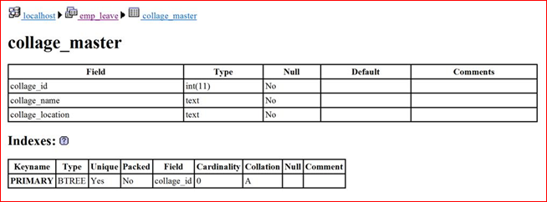

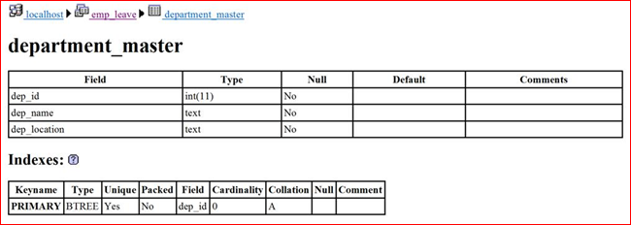

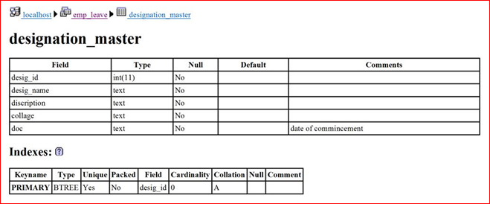

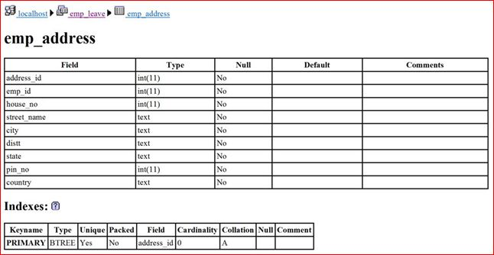

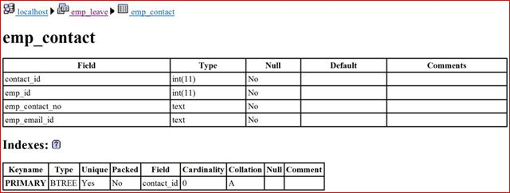

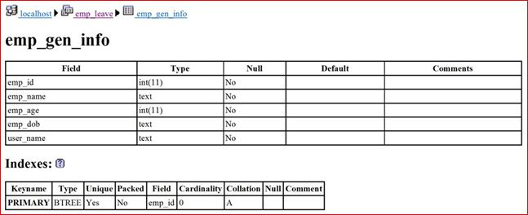

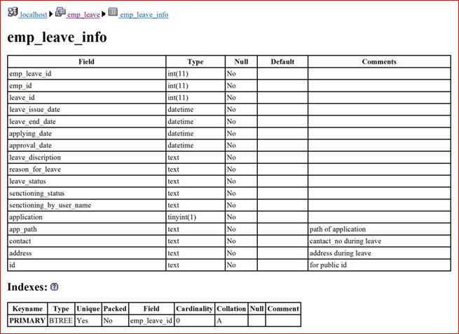

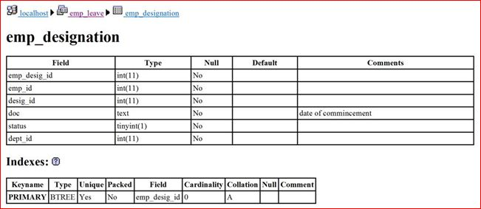

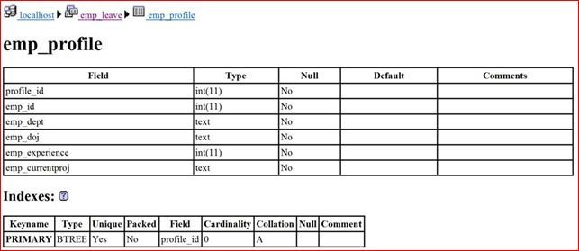

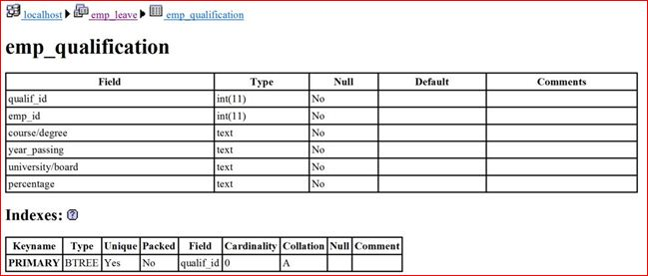 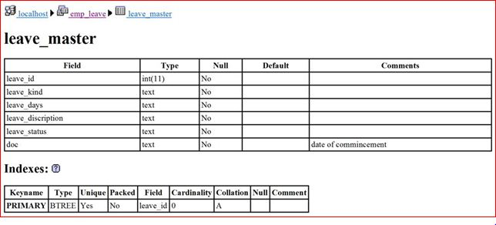

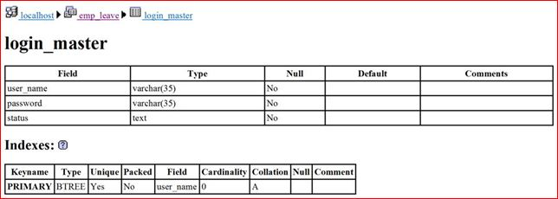

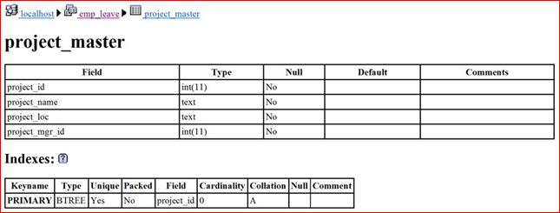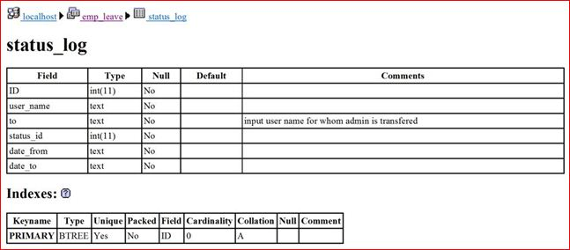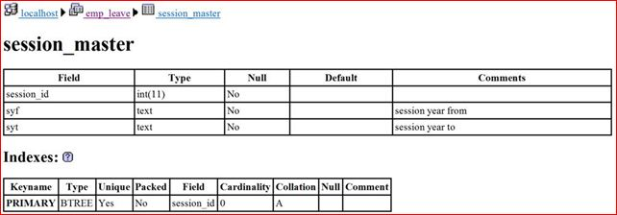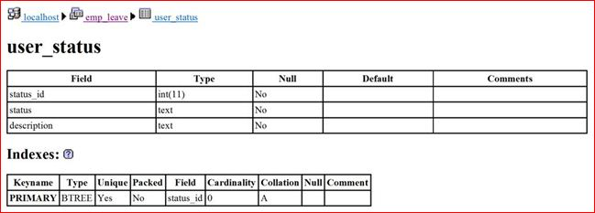**TEST CASES**

**Test Cases 1:**

**Module Name** – Login Module.

**Test Designed By**: abhay

**Test Designed Date**: 17 Apr, 2013.

**Purpose**: Login the Existing System

**Pre-Condition**: Authorized person and have required input and output devices for input and output.

**Input:** Username” xxxx ” & Password “12345”

**Expected Output:** successfully login message or fail message are display.

**Post condition:** successful login and move to next module.

**Test Cases 2:**

**Module Name** – Test data of user name in Login Module.

**Test Designed By**: Abhay

**Test Designed Date**: 17 Apr,2013.

**Purpose**: Login the Existing System

**Pre-Condition**: Authorized person and have required input and output devices for input and output.

**Input:** Username” Abhay”

**Expected Output:** By entering Invalid user name then an error message should appear as “Please Enter Valid User Name”.

**Post condition:** Login process has been failed.

**Test Cases 3:**

**Module Name** – Test data in Login Module when all fields as blank.

**Test Designed By**: Abhay

**Test Designed Date**: 17 Apr,2013.

**Purpose**: Login the Existing System

**Pre-Condition**: Authorized person and have required input and output devices for input and output.

**Input:** Username” xxxx”

**Expected Output:** By leaving all fields as blank and on click Log-in button then mandatory symbol ( * ) should appear in front of Username and Password fields

**Post condition:** Login process has been failed.

**Test Cases 4:**

**Module Name** – Applying for leave.

**Test Designed By**: Abhay

**Test Designed Date**: 17 Apr,2013.

**Purpose**: Employee applying for the Leave.

**Pre-Condition**: Authorised person and have required input and output devices for input and output.

**Input:** login through Emp_id and password.

**Expected Output:** After sign in, the staffs can see their profile on screen. The staffs need to click leave application button**.**

**Post condition:** Employee successsfully applying for leave.

**Test Cases 5:**

**Module Name** – Check the leave result.

**Test Designed By**: Rakesh

**Test Designed Date**: 17 Apr,2013.

**Purpose**: Employee check the Leave balance.

**Pre-Condition**: Authorised person and have required input and output devices for input and output.

**Input:** login through Emp_id and password.

**Expected Output:** The staff does not intend to apply leave; he just wants to know his leave balance. The staffs also can take unpaid leave if they really need' leave.

**Post condition:** Employee successfully knows about the leave balance.